December, the 10th, 2004

-----------------------------------------------------
Safety Organisation and Emergency Plans
@
Gran Sasso National Laboratories
-----------------------------------------------------
[Roberto Tartaglia]

Introduction

The LNGS underground labs are located in Assergi, in L’Aquila County (Abruzzo Region), at about 140km east of Rome (1 hour by car on the Highway A24). The underground labs are located at about 1400m under the rock in the central massive of Gran Sasso, more precisely underneath the peak of Monte Aquila. | 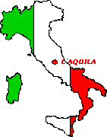

1. LNGS Configuration
As you can see from the 3D drawing (Figure n. 1), the 3 experimental halls, whose rough dimensions are 100 x 20 x 20 [m], are directly connected to the motorway public traffic with restricted access.
Figure n.1 – 3D Underground Labs sketch

This doubtless interference with the 10km highway tunnel can affect both the accesses to the underground lab, the maintenance, i.e. upgrading and reviewing of the main general plants (ventilation, power supply, data transmission, and optical fibres).
Moreover, the strict interconnection will limit the chance to assure the possible emergency escape way to all the labs users and visitors.
Because of this configuration, any emergency plan for the LNGS underground labs must keep into consideration the possible event scenarios: an accidental event in the underground lab and/or an event in one of the highway tunnels.
Any accidental event in one of the traffic tunnels can affect the stability and reliability of the lab plants and also the chance that fire brigades, motorway tunnels operators, and emergency rescue teams can reach the underground labs themselves. Any accidental event in the underground labs must be studied and afforded keeping in mind that the closest firemen stations are located in L’Aquila and Teramo, at about 30min from the labs (it’s really a huge amount of time to interact).

2. The LNGS Activities
Before describing the number of activities developed in the halls with their own intrinsic risk, let me say something about the labs and their users. The Gran Sasso National Laboratories are the biggest and most important underground labs in the world; they are unique in this working field.
The main difference with the other experimental labs in the world is due to the fact that the LNGS are not an ancient or current mine (as it is in Japan-Kamiokande or in Canada- SNO); in fact, they have been especially built for this purpose. The design and the Government approval and funding were possible thanks to the simultaneous highway tunnel construction in this area at that time.
The LNGS realisation started in 1982 and the first experiment construction started only 4 years later, in 1986, when the first tunnel was opened to the public traffic. At this moment there are 15 experiments currently running in the 3 experimental halls and in some of the interconnecting tunnels.
As regards the LNGS activities we can make the following remarks:
- currently 60 - 70 employees;
- an amount of 700 researchers coming from all over the world are co-operating to the different experiments installed;
- one group visit per day (50 people per day, above all scholarships), which means 10.000 people/year visiting the underground labs – visits have been stopped since May 2004;
- external companies continuously working at the lab (about 40 people/day).
Because of the situation described above, the Safety management has been organised in the following way:
- guards and firemen attending the underground labs 24h/day (5 people);
- people trained for Safety purposes;
- emergency team and on-call technicians;
- Group Leader In Matter Of Safety (GLIMOS) elected for each experiment;
- training courses for visitors’ guides (before the “stop”).

In the LNGS configuration it is extremely important to organise frequent training courses and Safety briefings; in the future there will be a “check-out” form which users must fill out as a proof of their acknowledgement.

3. The LNGS Organisation Chart
The LNGS organisation chart includes two groups dealing with “Safety subjects” in the labs activities:
-A- the “Special Safety Plants Group”
-B- the “Prevention and Protection Group”.
The group –A– takes care of the technical plants in the labs, of their design, their upgrades and maintenance.
The group –B- takes care of the following items:
- organisation and lecturing for information and formation courses for all the LNGS users;
- Safety procedures to be studied and adopted;
- interaction with the external entities (Firemen, policemen, Highway tunnel Company) and Experimental Collaborations
- Risk Assessment and evaluation.

4. The Highway Tunnel Safety Systems.
As it has been shortly described in the introduction, the LNGS configuration requires a strict interaction of the LNGS Safety group with the highway tunnel Companies, firemen and policemen, so that it will be possible foreseeing and establishing every single step of the emergency procedure well in advance.
Several meetings have been held and an emergency plan has been studied, agreed and adopted. The emergency plan keeps into consideration both the LNGS Safety plants (Franciotti- ref. *2) and the highway tunnel Safety systems which are described as follows.
The remote control centre is located close to the motorway exit in Assergi and is attended 24h/day. A ventilation plant has been realised on both the tunnels; the maximum air speed reachable is of about 70km/h, but it is not possible to reverse the air-flow direction.
Along the tunnels a thermo-sensitive cable is present (the alarm set-point has been fixed @ 70°C); the cable has been segmented in short bunches 200m long which let the operator identify the alarmed zone with high accuracy. Along the 10km tunnel there are also 18 cross-road tunnels which connect the two tunnels; a closed circuit video system has been realised, too: there’s a video-camera each 200m, the monitors are in the remote control centre. Moreover, along each of the 2 highway tunnels there are 33 Safety corners provided with a portable extinguishing system and intercom connections. Along the tunnels there are also 7 venting stations (a “ring-loop” power supply system let them to be powered even if one of them fails). All the systems described are regularly tested and maintained; a close interaction between the motorway tunnel operators, the policemen and the fire brigades is required, in order to act the emergency plan in the fastest and most correct way. Both the accidents at Mont Blanc tunnel and in Austria tunnel have shown that the foreseen and realised Safety systems are not enough, if it is not possible to reach the event zone in a fast way. Even if dangerous and toxic materials are not allowed or require special escorting, we must keep in mind that also margarine and hair spray have proven to be extremely dangerous goods.
Most of the LNGS plants are running along the tunnel’s part which connects the Teramo side to the underground labs (4.5km tunnel).
There is a venting duct with a diameter of f=1500mm running along the upper part of the tunnel, useful for the normal venting condition. Moreover there’s a venting pipe (f=800mm), always running along the roof of the tunnel, from the Ruzzo cave up to the underground lab access (2.5km pipe), which is used for emergency operating conditions. Furthermore, the power supply cable and the data transmission cable and optical fibres are running along the tunnel itself.
For this reason, the connection and the communication between the remote control rooms must be very well organised, with a redundant system which is as safe as possible to work also in emergency condition. Any car accident in the tunnel could cause some damages to the labs plants and/or some problems for the escaping procedure to the LNGS users; on the other hand, each event in the underground labs could cause some interference to the public traffic.

5. Main Experiments @LNGS: materials adopted.
The underground labs are formed by 3 main experimental halls {named Hall A, B, C, whose dimension are 100 x 20 x 20 [m]} and a series of interconnecting tunnels (the emergency ones, the interferometric zone, the truck tunnel, the service tunnel and the car tunnel). Due to their huge dimensions, most of the experiments are allocated in the main halls, while the general servicing devices and supporting plants (water supply, power supply, and so on) are located as well as the cryogenics liquid tanks in the connecting tunnels. In the enclosed map you can see the experimental configuration: let’s describe in a short and schematic way the main experiments and their own intrinsic risk (in the present report we don’t deal with the Safety system in each hall).
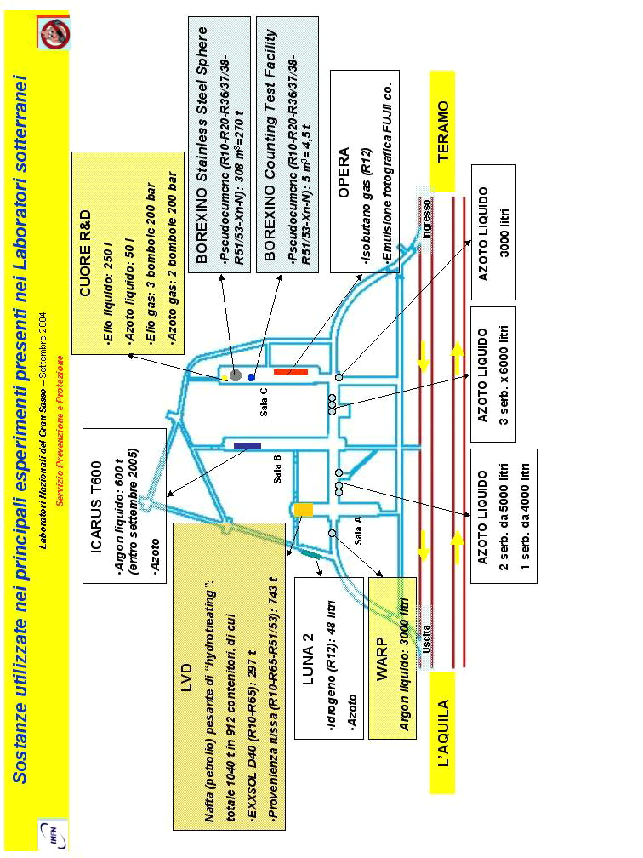
Fig. n. 2 – Substances general inventory

6. Confinement
The Experimental Halls are divided from each other and from the other tunnels by fireproof and explosion proof doors (dimension of 4.75m x 4.75m). Moreover, the underground labs are divided from the highway tunnel thanks to two fire-proof door lines. In correspondence with the 3 connections/accesses to the highway tunnel, these door-lines identify 3 safe places (n.1 at the access, n.2 at the exit, n.3 in the middle). These safe places, which are divided both from the highway and from the labs, are the temporary gathering places in emergency cases. The main safe place (n.1) is attended 24h/day by more than one operator; it’s vented with air coming directly from outside (external make-up air) and it hosts the remote control systems and the connection with the outside world.

7. Ventilation System in the Underground Labs.
The venting station of the LNGS ventilation system is located at Casale S. Nicola, on the Teramo side, just above the highway tunnel. The LNGS venting plant permits to ventilate the 3 underground halls with fresh air from the Teramo side with an average flow-rate of 40.000 m³/h thanks to 2 ventilators and a f= 1500mm venting duct running along the upper part of the highway tunnel. The maximum allowed flow-rate is 80.000m³/h in emergency case (4 vent engines instead of 2). As one can see from the Figure n. 3, in case of an accidental event, reversing the flow-rate is possible, so that it is also possible to suck the air from the underground labs towards the outside world with a maximum flow-rate of 60.000m³/h (e.g. for smoke exhausting).
The flexibility of such a system also permits to assure a slight overpressure in the halls in normal operating condition and a slight under-pressure in the hall where the accident has occurred, sucking air directly from the highway tunnel. In emergency conditions it is also possible to assure a minimum air flow to the halls not affected by the accident. This is possible thanks to a second duct (f= 800mm) which sucks in air from the Ruzzo tunnel, at about 2.5km from the access to the underground labs (it is the Teramo water system tunnel).
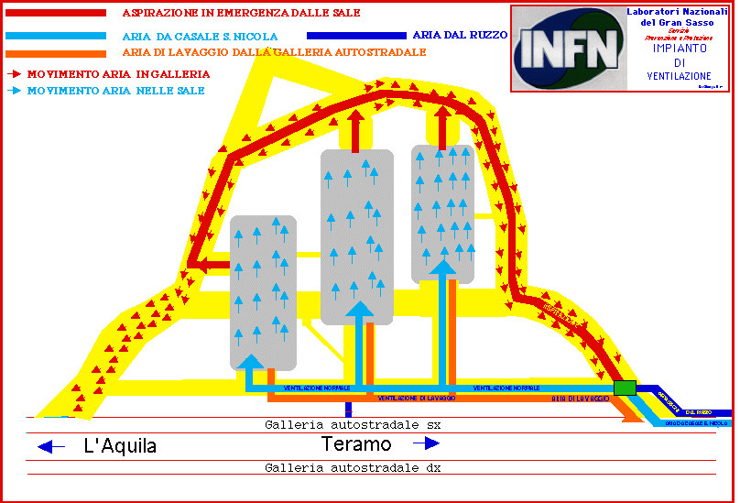
Fig. n. 3 – Ventilation Plant Sketch

8. The LNGS Emergency Plan
All that which has been described and discussed, including the Safety plants already installed and/or in the realisation phase have been kept into consideration during the editing and publishing of the LNGS emergency plan, agreed with the local Authorities.

